Preschool & Toddlers Pack
‘Broken Image Bearers – Genesis 3

Hi Parents,
This week we are continuing our ‘meant to be series’ and are looking at how God’s creation becomes broken and what this means for us now.

Here are some activities for your preschoolers & toddlers to do, watch and listen to during Church today.
- Look at the pictures on page 5, look at them online or follow along with the bible reading using a children’s picture bible.
https://www.freebibleimages.org/illustrations/adam-eve-fall/

- Make a snake by threading pasta tubes or cut up straws onto string.

Use playdough to make a snake

Make a garden out of duplo and put some people in the garden.

- Listen to the story from the Jesus Story Book Bible

https://www.youtube.com/watch?v=XYsVYg3mdPo (Chapter 3 – the Terrible Lie – Audio Only)

https://www.youtube.com/watch?v=-sZPlFNbktM (Jesus Storybook Bible – To watch & Listen)

- Watch a short video on Genesis 3/Adam & Eve’s Sin

https://www.youtube.com/watch?v=l7TDvJrjjz0 (Saddleback Kids)

https://www.youtube.com/watch?v=Kg2lkCxjMg8 (Gods Story/Crossroads Kids Club)

Or something longer from the beginners bible
https://www.youtube.com/watch?v=D9oh4YO8N7M

- Draw the Garden, the snake and Adam & Even on the next page or colour in the picture on page 3.

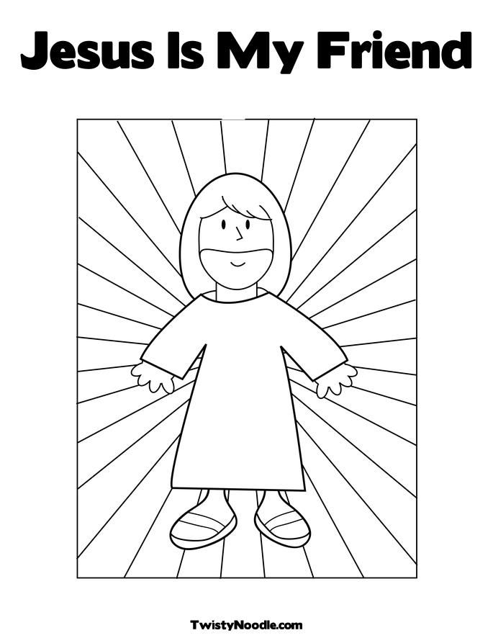
Craft Time

- Make a pasta snake – using wool or string, pasta, and coloured textas.

Satan told a lie about God to Eve. Eve believed the lie, doubting God’s truth and disobeyed God.

- Make a mirror using a paper plate and some foil

Jesus is the perfect image of God and we are being made like Jesus.

