Kids Talk Outline
Anthropology – Meant to be

Hi Everyone
Thanks so much for giving our Kids Talk this week. Kids Talks are a moment when we can encourage, teach and delight in our children as well as learn in a clear, creative and visual way as whole church family. Kids talks are also a touch point for our adults to discuss with our children about what we are learning at Church and they model to parents the way we teach and apply God’s word to children.

Here are a few tips for preparing and giving a kids talk.

Preparing well

- Pray and read the passage as few times, read through the Kid’s Talk outline.

- Make sure you have one big clear idea and think through how you will illustrate this. Aim to make Jesus the highpoint and link the illustration through to him and us.

- Remember we are just introducing the big idea/theological concept or narrative we are learning about - the detailed teaching will happen in the sermon and kids church.

- Practice your kids talk a few times – we are aiming to keep them to 3-4 minutes

- Any visuals need to be large so everyone can see them (if you want them on the screen they need to be sent to Curtis by COB Wednesday)

Giving a Kids Talk

- Check in with the sound desk about your microphone – use the headset and handheld microphones for anyone assisting

- Join pre-service prayer

- At the beginning welcome the children to the front and introduce yourself

- Address and speak to the children (while we are all learning together as a church family– keep your eyes and language toward the children in front of you). We are aiming the kids talks at about preschool - kindy aged, knowing there are babies right through to year 6’s participating.

- At the end you are going to send the children off to kids church – see the blurb at the end of the kids talk for the most helpful way to do this

- Get some feedback – chat with the MC or congregational pastor, Naomi or a Kids Church Team leader for feedback to be encouraged and keep growing.

- Feel free to contact me during the week to chat through ideas, I’m happy to help you prepare and practice or put you in touch with someone else who can.

Kids Talk Outline

Bible Passage: Gen 3

Key Idea: we are made to be like Jesus, the perfect image bearer

Props: Morphsuits x2, snake, mirror – make it look cracked with paint pen or sharpies and crowns x3, bible

- Introduce
Welcome Kids

Today are continuing our series on what the bible teaches us about people. We are going to pick up from where we left last week..

We saw that as people, made in God’s image we are very special. All that God made was very good.

- Explain (the key idea we are learning from the bible)

The people God made were to be his image bearers. (Morph people, with mirror and crowns)

They were to be God’s representatives, to stand in the place of God, to rule God’s world like God and loving the things that God does. (crowns)

Being in God’s image they had perfect relationship with God and each other. (hug each other)

- Illustrate (illustrate the key concept it in a simple, visual way)

But the people God made sinned. (Act out talking to snake and eating fruit from tree)

They turned from being God’s image bearers, to being God’s image breakers. (draw on mirror)

They decided to rule God’s world in their own way (change crowns) and failed to be God’s representatives, loving and living in God’s ways.

People’s relationship with God and each other was broken (morph people point fingers and fight)

God’s image was broken, God’s heart was broken. (break mirror here?)

- Link to Jesus & to Us

The people God made were not just representatives of God in his world. They were also representatives of every single person, they stand in the place of all humanity, the represent you and me.

Their actions and attitudes towards God, their sin, represents all of us, we have the same actions and attitudes. Because of our sin, we are broken image bearers and failed representatives too.

That is why God sent Jesus, his perfect son. To be a new representative, a new Adam. To be the perfect image bearer, the perfect representative.

To be what we could never be. (illustrate this some how) – new perfect mirror

As Christians, followers of Jesus, we are made new, new people. People who are no longer like Adam, but like Jesus. People who like Jesus, reflect God’s image, and represent him to the world

Jesus is such good news for us and for our world.

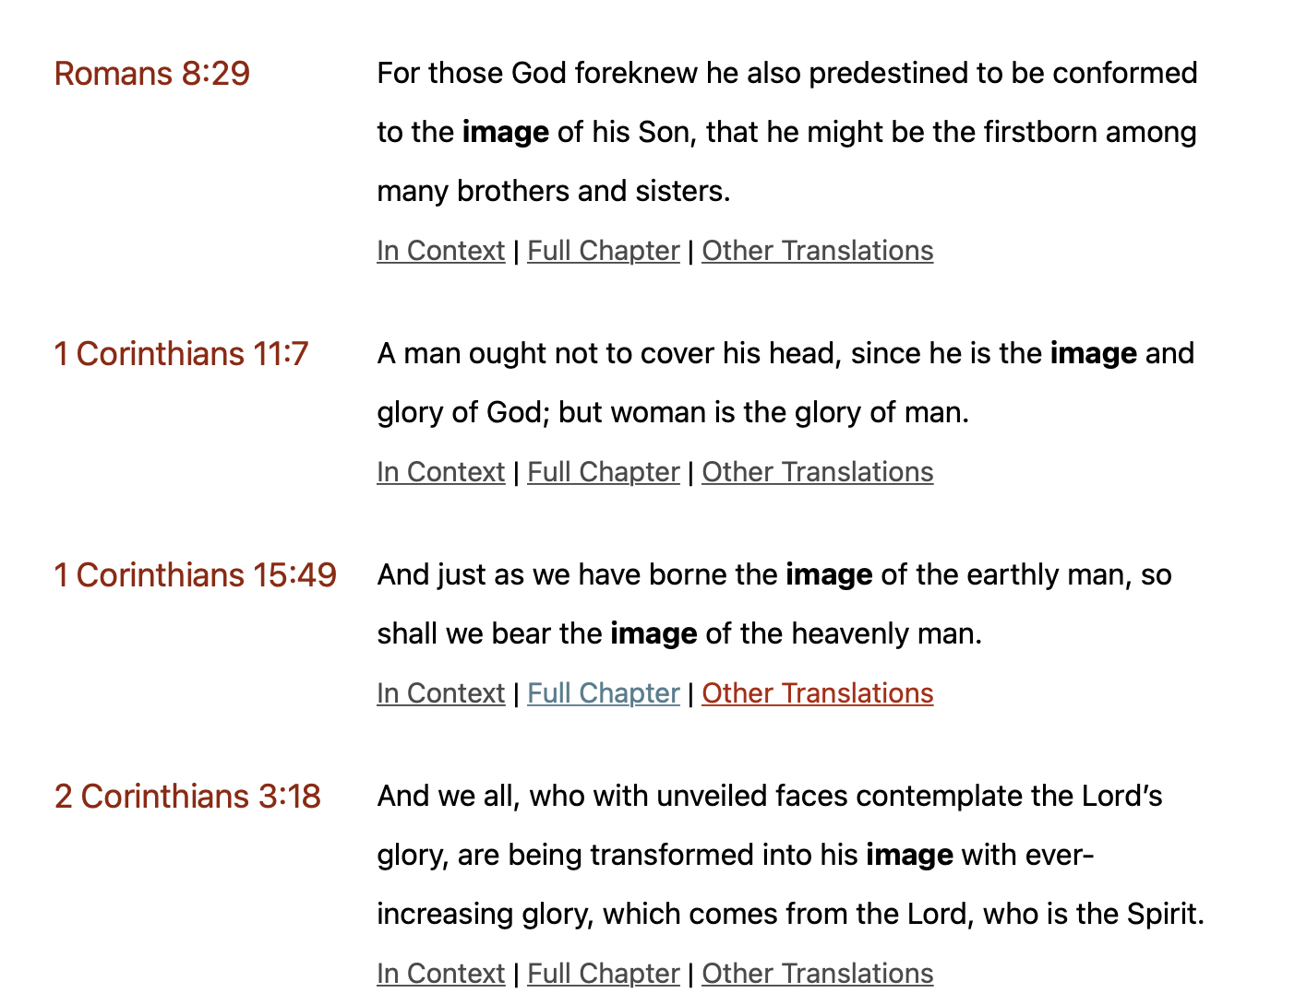

- Reinforce

Let’s pray and thank God for Jesus, who makes us like him.

- Pray

- Send Kids Out to Kids Church

